JAVA
TWO SUM:
CODE:
import java.util.*;
class twosum{
public static void main(String[] args){
Scanner s=new Scanner(System.in);
int n=s.nextInt();
int[] arr=new int[n];
for(int i=0;i<n;i++){
arr[i]=s.nextInt();
}
int left=0;
int right=arr.length-1;
int target=9;
while(left<right){
int sum=arr[left]+arr[right];
if(sum==target){
System.out.print(left+","+right);
return;
}
else if(sum<target){
left++;
}
else{
right--;
}
}
System.out.println("-1,-1");
}}
OUTPUT:
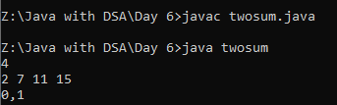
DUPLICATE:
CODE:
import java.util.*;
class duplicate{
public static void main(String[] args){
Scanner s=new Scanner(System.in);
int n=s.nextInt();
int[] arr=new int[n];
for(int i=0;i<n;i++){
arr[i]=s.nextInt();
}
int left=0;
int right=1;
while(right<arr.length){
if(arr[left]!=arr[right]){
left++;
arr[left]=arr[right];
}
right++;
}
for(int i=0;i<=left;i++){
System.out.print(arr[i]+" ");
}
}
}
OUTPUT:
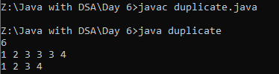
PALINDROME:
CODE:
import java.util.*;
class palindrome{
public static void main(String[] args){
Scanner s=new Scanner(System.in);
String str=s.nextLine();
int left=0;
int right=str.length()-1;
boolean found=true;
while(left<=right){
if(str.charAt(left)==str.charAt(right)){
left++;
right--;
}
else{
found=false;
break;
}
}
if(found){
System.out.print("palindrome.....");
}
else{
System.out.print("Not a Palindrome.....");
}
}
}
OUTPUT:
